**Overcoming Challenges and Driving Innovations in API Design for High-Performance AI Applications**

**Abstract**

The research presents new research and practices for enhancing API functionality in high performance AI applications. This can address the issue by exploring techniques such as micro services architecture, asynchronous processing and edge computing to make things efficient and scalable. It also studies the way API performance can be balanced with the help of advanced data serialization method, load balancer and caching. It discusses best practices such as API versioning, rate limiting and security protocols to make sure the system is reliable under the high loads of traffic. The research demonstrates that any continuous innovation in API design is imperative to cater to the evolving needs of AI systems for faster response times and better system performance.

***Keywords: API, AI, Performance, Microservices, Optimization, Architecture, Efficiency, Latency, Scalability, Design***

**INTRODUCTION**

APIs designed for high-performance artificial intelligence applications become difficult to develop because AI systems possess intricate characteristics. The implementation of high-performance AI systems requires solutions to tackle three fundamental issues that are data set management, low-latency operations and scalable architecture design. High-performance AI applications need effective component-to-component communication that requires the implementation of advanced API plans. API design innovations serve to tackle existing challenges and deliver better performance results. The operation of AI systems becomes effective to optimize data handling and streamlined processes and improved flexibility provided by APIs.

**Aim**

The aim of the research is to investigate the problems and breakthroughs in API design for high-performance AI systems, with an emphasis on performance optimization and scalability.

**Objectives**

* To Identify the major issues in creating APIs for high-performance AI applications, with an emphasis on scalability
* To explore the effect of efficient API design on high-performance AI systems
* To examine novel methodologies and tactics that improve API functionality for high-performance AI applications
* To recommend best practices for API design that promote speed, scalability and efficiency in high-performance AI systems

**Research Questions**

* What are the key obstacles in developing APIs for high-performance AI applications, particularly scalability?
* How does an effective API design affect the performance and efficiency of high-performance AI systems?
* What new processes and strategies can help improve API functionality for high-performance AI applications?
* What best practices can be suggested for increasing speed, scalability, and efficiency in high-performance AI systems?

**RESEARCH RATIONALE**

The difficulty of integrating different AI components leads to challenges in the time of creating high-performance AI application APIs. System growth introduces fundamental obstacles for the management of data flow alongside requirements for system scalability. API inefficiency in the time of dealing with big information sets and fast response times becomes an obstacle to effective AI application functioning [1]. Multiple issues restricting API system complexity led to delayed systems and decreased scalability along with inferior resource management. API design effectiveness acts as an important factor for enabling smooth communication between AI components that enhances their operational effectiveness.

**LITERATURE REVIEW**

**Key Challenges in Designing APIs for High-Performance AI Applications and Focusing on Scalability and Efficiency**

The implementation of efficient APIs for high-performance AI systems encounters essential difficulties because of scalability requirements and efficiency demands. Scalability problems emerge because of increasing AI system complexity and size demands that APIs process large data quantities and meet processing requirements. Traditional APIs have performance limitations due to their inability to maintain low latency communication and data flow in the time of AI applications evolve [2]. Large datasets create more challenges for API transmission and distributed system data processing because these operations can run efficiently. The essential concern for APIs involves both component intercommunication support and utilizing resources in the most efficient way possible.

API design flaws create resource wastages that generate both computing power and memory waste. The performance of AI systems that need real-time processing depends heavily on any performance-related delays that occur in the system. APIs need to support multiple AI models that require different specifications regarding data format along with processing capabilities and system specifications [3]. Keeping an API adaptable between various models with efficient scalable features makes the design process more complex. API design for high-performance AI systems faces scalability and efficiency as its core fundamental problems when created.

**The Impact of Efficient API Design on the Performance and Scalability of AI Systems**

Efficient application programming interface design is critical for increasing the operating speed and capacities of artificial intelligence systems. The flow of data optimization with minimization of latency becomes possible through well-designed API architecture that increases the speed of AI system component communication [4]. The speed increase through efficient AI systems allows processing of data at a faster rate particularly during real-time decision-making applications. The efficiency of APIs decreases computational overhead thus managing resources properly while preventing performance losses caused by substandard communication protocols.

The main advantage of well-designed APIs involves scalability as a core attribute. AI systems can be able to manage large amounts of data while also providing efficient performance. API design with efficiency features allows for horizontal scaling that enables artificial intelligence systems to scale while preserving their operational integrity [5]. These APIs establish distributed architecture that enables systems to instantly distribute resources depending on demand requirements thus attaining scalability with no degradation of performance. Codes designed efficiently allow AI systems to link smoothly with other services alongside platforms.

**New Methodologies and Approaches for Enhancing API Functionality in High-Performance AI Applications**

The development of new methods for high-performance AI applications through APIs targets three core areas that include data management solutions alongside system coordination enhancement and resource management improvements. APIs have become more manageable because of new microservices models that divide them into smaller, distinct services [6]. The service-oriented model provides better scaling potential because independent components handle different processes leading to accelerated time response. Microservices break down activities into smaller components to reduce system dependencies and improve scalability and performance levels.

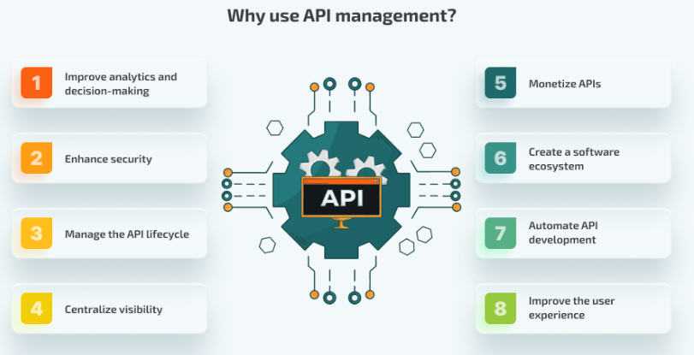

**Fig 1: API Management Approaches**

The API query language GraphQL enables clients to fetch precisely the needed data through its request capabilities. The implementation of GraphQl improves API performance by avoiding useless data transmissions and therefore improves processing speed for AI applications. The integration of GraphQL lets users extract information from AI models through highly versatile and efficient API connections in the time of working with extensive data collections [7]. The adoption of serverless architecture continues to grow as a suitable solution for designing APIs in AI applications. Computing operations require less server administration since the system automatically increases or reduces resources based on demand with serverless. The API runs optimally at peaks with greater efficiency to its cost-effective utilization of computational resources.

**Best Practices for API Design to Optimize Speed, Scalability, and Efficiency in AI Systems**

Optimizing high-performance AI systems necessitates excellent API design methods that priorities speed, scalability, and efficiency. API design efficiency depends largely on adopting data formats that include JSON or Protocol Buffers. The utilization of these data formats minimizes overhead during serialization operations and enhances transmission fastness through better data speed for applications that handle massive datasets [8]. The reduction of API data volume enables faster information processing and transmission leading to better overall system response speed.

API deployment can include rate limiting mechanisms together with caching solutions. The rate limiting system enables API operations to maintain their stability regardless of high traffic conditions by regulating the maximum number of requests received within specified timeframes. Data caching functions as an optimization method that keeps regular database queries to decrease latency when processing requests. Real-time AI applications require these practices to optimize API performance that decrease the amount of time needed for responses [9]. Scalability improvements happen in the time of APIs adopt modular designs allowing maximum flexibility within their protocols. Microservices design allows individual API components to evolve independently for maximum resource utilization. A well-implemented distributed system traffic load balancing method uses available servers to maintain performance growth while demand increases. Efficient AI systems at scale will reach operational success through implementation practices designed for high performance operation.

**Literature Gap**

Research on high-performance AI system API design currently focuses its efforts upon separate functional aspects such as scalability and efficiency. Research fails to integrate these factors into complete whole systems. Research into implementing high-performance AI applications using microservices and serverless architectures has not gained sufficient practical focus. Research documents theoretical benefits without discussing practical hurdles and compromise factors.

**METHODOLOGY**

The research adopts “***Secondary data sources”*** because comprehensive information from publications and reports and studies exists about API development along with AI system operations. The existing research investigation under this method enables thorough examination of API design practices at present. Secondary data is a useful data source due to its extensive industry coverage, speedy research procedure, and low cost [10]. The researcher chose ***“interpretivism philosophy”*** because it focuses on analysing human actions together with their contextual meanings. The interpretivist philosophy enables investigators to study professional’s personal API design experiences within the field to discover complex aspects about AI system API development practices. The chosen approach has unique relevance to explore complex phenomena developed through social interactions within technological environments.

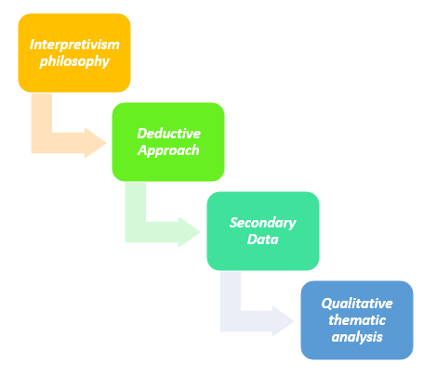

**Fig 2: METHODOLOGY**

The researchers use ***deductive approach*** to test well-established theories about API design and scalability as well as efficiency. Existing research guides the development of a starting hypothesis that gets verified or disproved by analyzing secondary information sources. A structured research of high-performance AI systems in reference to their response to API design principles can be achieved through this method. The collected data goes through “***Qualitative thematic analysis”*** that enables researchers to identify and analyze major themes together with their patterns. The thematic analysis utilizes this method because it delivers exhaustive analysis of the qualitative clues concerning API design [11]. Data patterns in the collected information enable researchers to establish important findings about the best approaches and difficulties alongside innovations within AI system APIs.

**DATA ANALYSIS**

**Analysis of Key Issues in Designing APIs for High-Performance AI Applications with a Focus on Scalability**

API development for high-performance AI applications presents important challenges that become evident in the analysis of design issues especially for scalability purposes. The necessity for scalable systems becomes increasingly important as AI applications analyze large datasets at fast rates between linked components [12]. The scalability of traditional APIs fails in the time of dealing with such demands because this lacks sufficient capability to handle growing amounts of data. The system cannot perform efficiently in real-time data processing situations because of these restrictions.

APIs face the main issue of sustaining fast communication alongside extensive data network transfers. AI systems struggle to maintain smooth data exchange between separated systems as they continue developing in size. API systems need functional capabilities to distribute operations between multiple servers or nodes for managing increased data throughput effectively. The main drawback of current API systems stems from their weak adaptability features to different requirements. Traditional APIs have a disadvantage that are unable to adapt to varied data structures and processing protocols, whereas AI relies significantly on multiple methods and data formats [13]. Efficient scalability becomes challenging for APIs that operate within a rigid framework because their systems develop.

**Evaluating the impact of efficient API design on the performance and scalability of high-performance AI systems.**

The performance and scalability of high-performance AI systems can be evaluated to quantitate the impact of APIs in a system’s optimization in the presence of efficient API design. Efficient API design for the AI components data flow significantly reduces communication delay and improves the system performance. A well-designed API reduces the latency required for quicker processing of massive datasets that is important for AI applications that rely on real-time judgements. Efficient APIs minimize the amount of computation necessary for optimum resource utilization [14]. This efficiently reduces data transmission to prevent unwanted resource wastage and enhance the overall performance of the AI systems. It is especially important for AI systems that operate with large volumes of data or in fast changing contexts, as every millisecond counts.

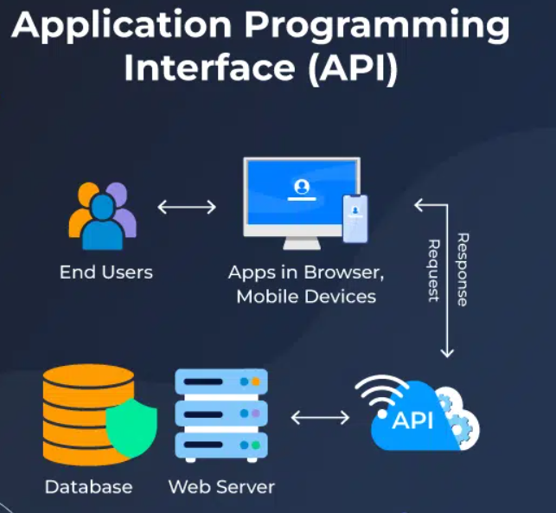

**Fig 3: Application of the API Management**

Efficient APIs help horizontal scaling and thus AI systems can smoothly grow without any thought on impact on the performance. These APIs allow resources to be allocated dynamically on demand, enabling scalability of these systems on demand that is increasing in scale. The flexibility is that AI systems are still able to keep operational integrity in the time new data is added [15]. The summary demonstrates that it is essential to have efficient API design to achieve the same level of performance or scalability in high performance AI systems.

**Investigating novel methodologies and techniques for improving API functionality in high-performance AI applications.**

It is about investigating novel ways of increasing efficiency and scalability of API functionality in high performance AI applications. Microservices designs can promote modularization using sophisticated approaches, resulting in speedier development and simpler maintenance. Adopting asynchronous programming models also enhances API responsiveness since many requests can be handled concurrently and thereby latency can be reduced [16]. The methods of data serialization in an efficient way like Protocol Buffers can save bandwidth, data transmission between clients and servers faster. High-performance AI apps can bring expanded API functionality, faster response times, more scalability and better user experiences using these sophisticated approaches [17]. One can employ AI-driven optimizations like dynamic load balancing and anticipatory scaling to ensure that the API stays operational during periods of heavy demand. Accommodating serverless architecture increases flexibility by automatically scaling on demand for greater resource usage. APIs instead of RESTful APIs reduces a lot of data fetching and makes it more efficient to request the data using GraphQL.

**Identifying Best Practices for API Design to Improve Speed, Scalability, and Efficiency in AI Systems**

Finding the best practices on API design is important to make AI systems faster, scalable and effective. Optimize endpoint structure by having a simple and concise design, thereby reducing the complexity. It makes the upgrade simpler and not affecting the current users by implementing proper versioning and backward compatibility. One can achieve data retrieval efficiently in little response time and save the overhead of wastage of unnecessary data by using RESTful or Graph QL API. A rate limiting can make sure the API can withstand high traffic loads without corrupting the system [18]. Asynchronous processing in the API call allows for non-blocking operation of requests, thereby increasing the system overall performance by allowing multiple requests to be processed at the same time.

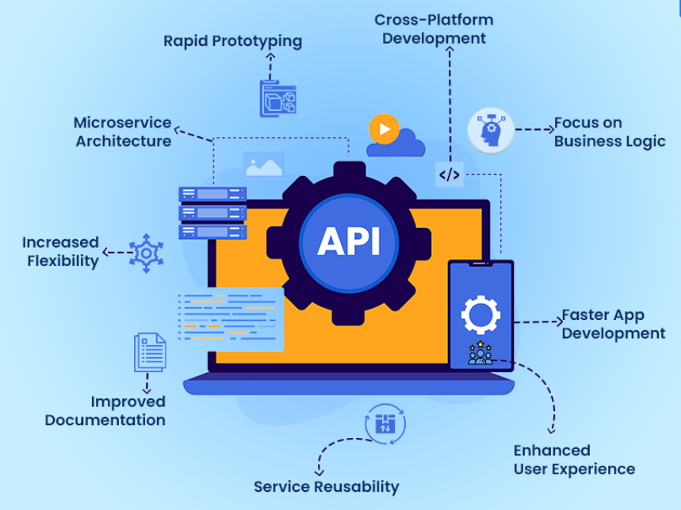

**Fig 4: Advantages of API Development**

Caching often accessed data helps in reducing recalculating redundant data that contributes to efficiency. APIs are also secured with strong authentication techniques such as Auth to ensure safe data sharing and improved speed. It can help to distribute the requests evenly across the servers to keep availability high and response time low during peak time. Communication speed and latency are optimized by optimizing data serialization formats such as Protocol Buffers [19]. The performance of these AI systems is largely ensured as this can respond to one faster, be scalable and reliable for different use cases following these best practices.

**FUTURE DIRECTIONS**

Future design of high-performance AI systems with APIs entails more enhancements to AI based optimizations, e.g. predictive scaling and dynamic load balancing. Integration of next-generation microservices designs can promote increased modularity and flexibility, as well as scalability [20]. Edge computing and decentralized processing can minimize latency and improve real-time performance.

**CONCLUSION**

The above data concludes optimization of API functionality is key to improving system efficiency, speed and scaling in high performance AI applications. Advanced approaches like microservices, asynchronous processing, and edge computing can significantly improve API performance. The system can provide a reliable and efficient operation with the use of such best practices as proper versioning, load balancing and caching under high demand. The current API frameworks like GraphQL and enhancing data serialization can help to increase communication efficiency. The advancement of AI technology continues to influence the evolution of API design philosophies. This requires ongoing innovation to maintain top performance as complicated AI-driven systems mature.

**REFERENCES**

[1] Ranjan, P. and Dahiya, S., 2021. Advanced threat detection in api security: Leveraging machine learning algorithms. *International Journal of Communication Networks and Information Security*, *13*(1).

[2] Haji, S.H., Zeebaree, S.R., Saeed, R.H., Ameen, S.Y., Shukur, H.M., Omar, N., Sadeeq, M.A., Ageed, Z.S., Ibrahim, I.M. and Yasin, H.M., 2021. Comparison of software defined networking with traditional networking. *Asian Journal of Research in Computer Science*, *9*(2), pp.1-18.

[3] Shah, H. and Kamuni, N., 2023, December. DesignSystemsJS-Building a Design Systems API for aiding standardization and AI integration. In *2023 International Conference on Computing, Networking, Telecommunications & Engineering Sciences Applications (CoNTESA)* (pp. 83-89). IEEE.

[4] Cao, L., Kiani, A., Xiang, A., John, K. and Saboorian, T., 2022. Latency-aware End-to-end Multi-path Data Transmission for URLLC Services. *arXiv preprint arXiv:2210.13740*.

[5] Santoso, A. and Surya, Y., 2024. Maximizing Decision Efficiency with Edge-Based AI Systems: Advanced Strategies for Real-Time Processing, Scalability, and Autonomous Intelligence in Distributed Environments. *Quarterly Journal of Emerging Technologies and Innovations*, *9*(2), pp.104-132.

[6] Charankar, N. and Pandiya, D.K., 2024. Microservices and API Deployment Optimization using AI. *International Journal on Recent and Innovation Trends in Computing and Communication*, *11*(11), pp.1090-1095.

[7] Ambasht, A., 2023. API Integration using GraphQL. *International Journal of Computer Trends and Technology*, *71*(8), pp.28-33.

[8] Winata, A., Soeparno, H., Gaol, F.L. and Arifin, Y., 2024. Efficiency of Multi-Language Data Serialization for Hybrid Cloud-Edge HRIS. *Procedia Computer Science*, *245*, pp.28-38.

[9] Okuyelu, O. and Adaji, O., 2024. AI-driven real-time quality monitoring and process optimization for enhanced manufacturing performance. *J. Adv. Math. Comput. Sci*, *39*(4), pp.81-89.

[10] Feinberg, B. and Zanardi, M., 2022. Analysis of the Influence of Operational Costs on Increasing the Financial Performance of American Public Helath Corporation. *MEDALION JOURNAL: Medical Research, Nursing, Health and Midwife Participation*, *3*(2), pp.44-57.

[11] Byrne, D., 2022. A worked example of Braun and Clarke’s approach to reflexive thematic analysis. *Quality & quantity*, *56*(3), pp.1391-1412.

[12] Sharma, K., Salagrama, S., Parashar, D. and Chugh, R.S., 2024. AI-Driven Decision Making in the Age of Data Abundance: Navigating Scalability Challenges in Big Data Processing. *Revue d'Intelligence Artificielle*, *38*(4), p.1335.

[13] Vaghela, R.A., Solanki, K., Popat, R.R., Vaghela, I.R. and Chhangani, N., 2024. Usage of Modern API for Automization of Government Procedures. In *Transforming Public Services—Combining Data and Algorithms to Fulfil Citizen’s Expectations* (pp. 131-150). Cham: Springer Nature Switzerland.

[14] Tadros, M., Ventura, M. and Guedes Soares, C., 2023. Review of the decision support methods used in optimizing ship hulls towards improving energy efficiency. *Journal of Marine Science and Engineering*, *11*(4), p.835.

[15] Chowdhury, R.H., 2024. The evolution of business operations: unleashing the potential of Artificial Intelligence, Machine Learning, and Blockchain. *World Journal of Advanced Research and Reviews*, *22*(3), pp.2135-2147.

[16] Gokhale, S., Turcotte, A. and Tip, F., 2021. Automatic migration from synchronous to asynchronous JavaScript APIs. *Proceedings of the ACM on Programming Languages*, *5*(OOPSLA), pp.1-27.

[17] Santoso, A. and Surya, Y., 2024. Maximizing Decision Efficiency with Edge-Based AI Systems: Advanced Strategies for Real-Time Processing, Scalability, and Autonomous Intelligence in Distributed Environments. *Quarterly Journal of Emerging Technologies and Innovations*, *9*(2), pp.104-132.

[18] Brown, K.A., McGlohon, N., Chunduri, S., Borch, E., Ross, R.B., Carothers, C.D. and Harms, K., 2021. A tunable implementation of quality-of-service classes for HPC networks. In *High Performance Computing: 36th International Conference, ISC High Performance 2021, Virtual Event, June 24–July 2, 2021, Proceedings 36* (pp. 137-156). Springer International Publishing.

[19] Patil, K. and Desai, B., 2023. A Trifecta for Low-Latency Real-Time Analytics: Optimizing Cloud-Based Applications with Edge-Fog-Cloud Integration Architecture. *MZ Computing Journal*, *4*(1), pp.1-12.

[20] Adepoju, A.H., Eweje, A., Collins, A. and Austin-Gabriel, B., 2024. Framework for migrating legacy systems to next-generation data architectures while ensuring seamless integration and scalability. *International Journal of Multidisciplinary Research and Growth Evaluation*, *5*(6), pp.1462-1474.